Advanced Databases | Part 1 | Benjamin Wilson | C3444086

Table of Contents

Task 1 | Design 2

Star Schema and Identified Reports 2

The 4th Report example 2

Data Dictionary 3

Task 2 | Loading the Data sources 4

Data Source 1 LDS 4

Data Source 2 SU 5

Task 3 | ETL and Star Schema Loading Script 5

Star Schema Implementation 5

Staging Area 7

Designing the Audit Log 8

Load the data from the Leeds and Manchester placement tables. 11

Check the audit log for issues 12

Insert cleaned values into the final temporary table. 14

Populate the Dimensions 15

Populate the fact table 17

# Task 1 | Design

## Star Schema and Identified Reports

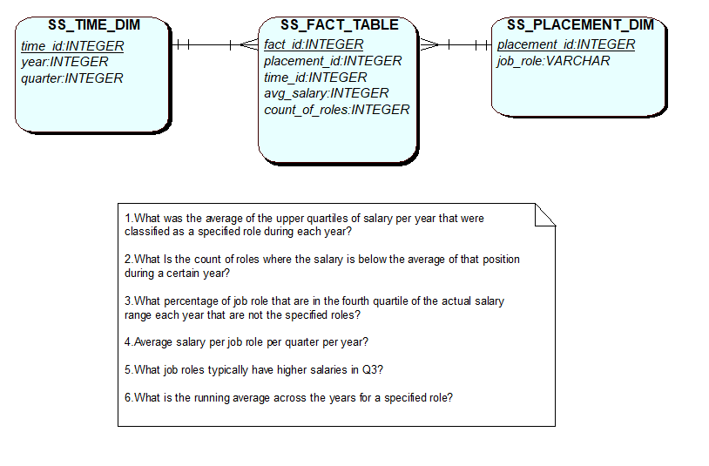

## The 4th Report example

Average salary per analyst type role per quarter per year?

SELECT job_role, avg_salary,quarter,year FROM ss_fact_table

INNER JOIN ss_time_dim ON ss_fact_table.time_id = ss_time_dim.time_id

INNER JOIN ss_job_role_dim ON ss_fact_table.job_role_id = ss_job_role_dim.job_role_id

WHERE job_role LIKE '%analyst%'

ORDER BY YEAR, QUARTER;

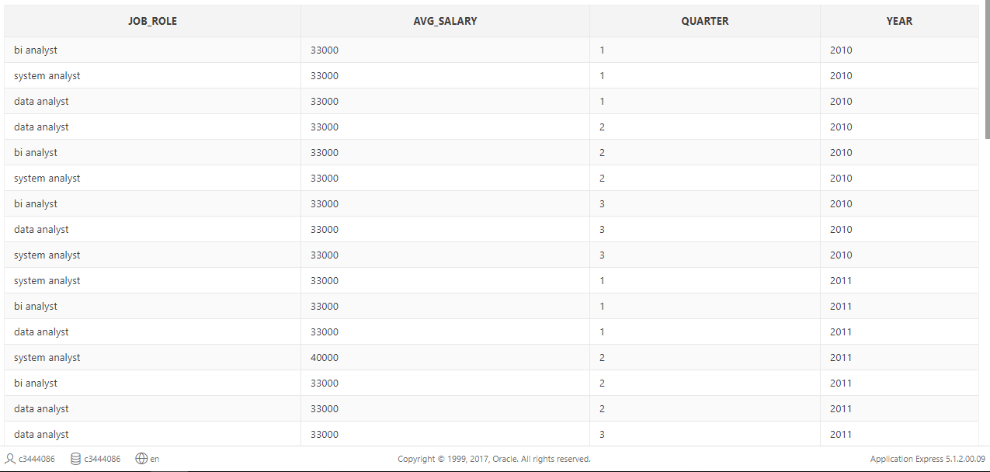

## Data Dictionary

|  |  |  |  |  |  |  |
| --- | --- | --- | --- | --- | --- | --- |
| Back Office | **Table Source(s)** | **Column** | **Type** | **Transformation(s)** | **Checks** | **Star Schema Destination** |
| placement_id | lds_placement  su_jobs | placement_id | VARCHAR2 | Concatenated a prefix to the id to avoid conflicts between the two sources. | UNIQUE, NOT NULL | Used for error checks in the audit log. |
| job_role | lds_placement  su_job | plt_job_role  plt_short_desc | VARCHAR2 | Job descriptions don’t necessarily represent the ***actual*** job role in the LDS table. Conversions to the description/roles have been done for consistency. Converted all of them to lowercase. This will help with doing a LIKE comparison when reporting. | NOT NULL, LOWER CASE | ss_job_role_dim.job_role |
| placement_start_date | lds_placement  su_jobs | required_start_date | INTEGER | The date has also been split up into Grouped into years and then quarters. | NOT NULL,  CORRECT FORMAT | ss_time_dim.year  ss_time_dim.quarter |
| actual_salary | lds_placement  su_jobs | actual_salary | INTEGER |  | Checked for any abnormal outliers. | Used to generate measure. |

# Task 2 | Loading the Data sources

Data Source 1 LDS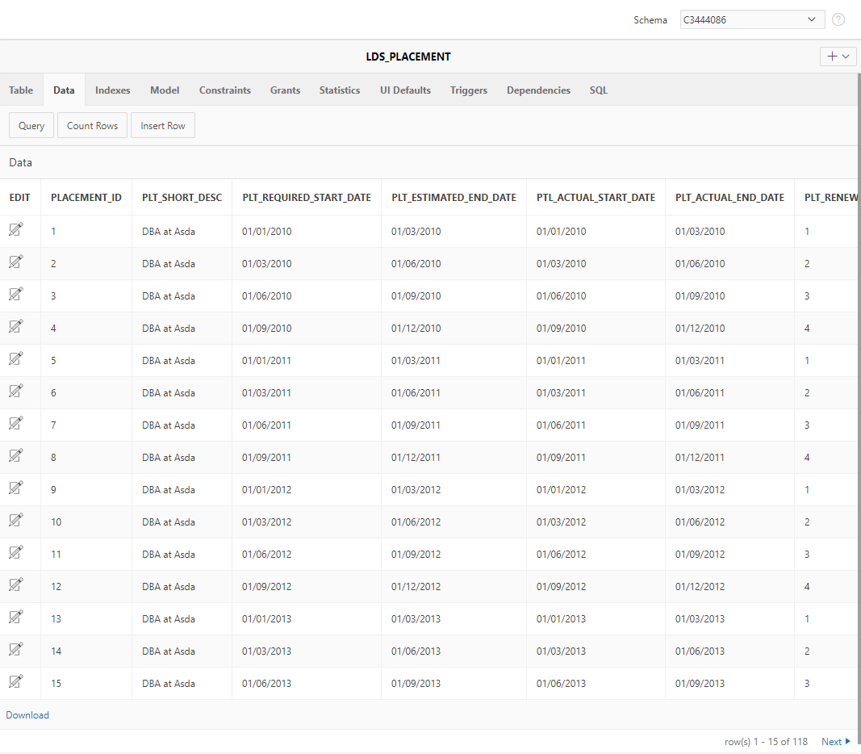

## Data Source 2 SU

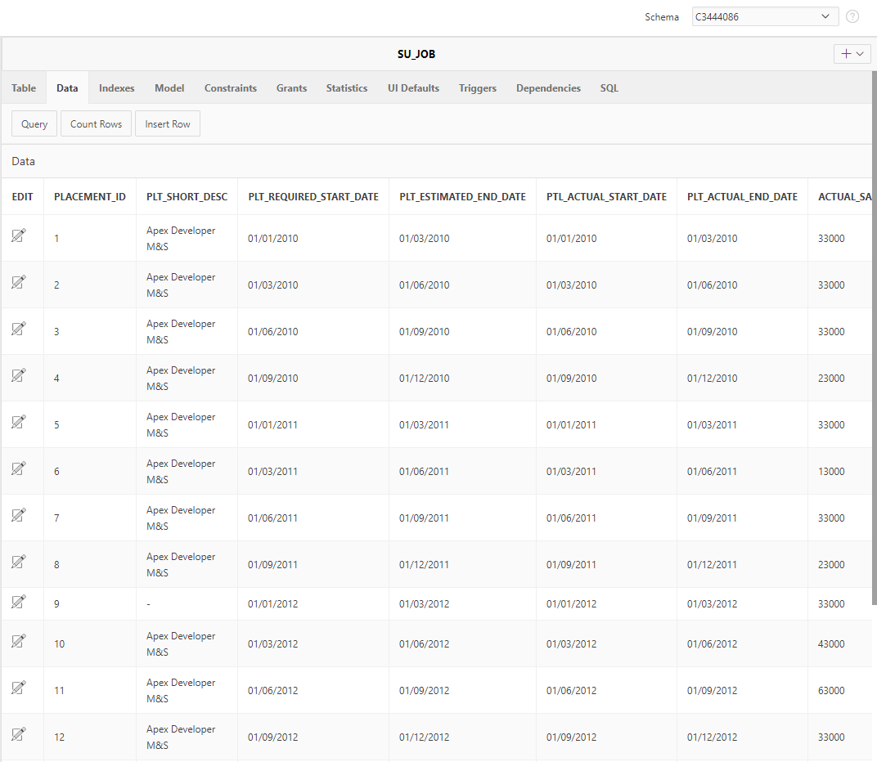

# Task 3 | ETL and Star Schema Loading Script

DROP TABLE SS_FACT_TABLE;

DROP TABLE SS_JOB_ROLE_DIM;

DROP TABLE SS_TIME_DIM;

DROP TABLE ss_temp_unclean;

DROP TABLE ss_temp_clean;

DROP TABLE ss_audit_log;

## Star Schema Implementation

DROP SEQUENCE job_role_dim_seq;

CREATE SEQUENCE job_role_dim_seq START WITH 1 INCREMENT BY 1;

CREATE TABLE SS_JOB_ROLE_DIM(

job_role_id INTEGER NOT NULL,

job_role VARCHAR(255) NOT NULL,

CONSTRAINT pk_SS_PLACEMENT_DIM PRIMARY KEY (job_role_id)

);

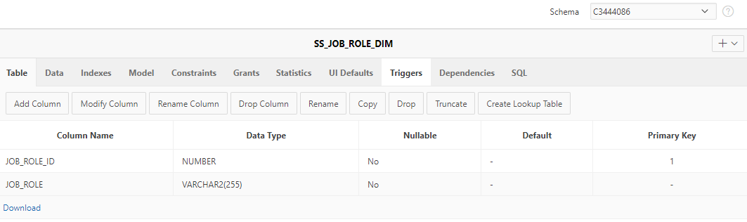

DROP SEQUENCE time_seq;

CREATE SEQUENCE time_seq START WITH 1 INCREMENT BY 1;

Dates type have been split up and cast into integers. This dimension supports more levels of granularity (quarter and year).

CREATE TABLE SS_TIME_DIM(

time_id INTEGER NOT NULL,

quarter INTEGER NOT NULL,

year INTEGER NOT NULL,

CONSTRAINT pk_SS_TIME_DIM PRIMARY KEY (time_id)

);

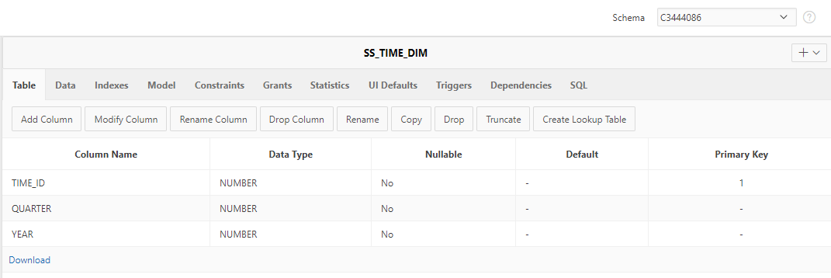

DROP SEQUENCE fact_table_seq;

CREATE SEQUENCE fact_table_seq START WITH 1 INCREMENT BY 1;

CREATE TABLE SS_FACT_TABLE(

fact_id INTEGER NOT NULL,

job_role_id INTEGER NOT NULL,

time_id INTEGER NOT NULL,

avg_salary INTEGER,

count_of_roles INTEGER,

CONSTRAINT pk_fact_id PRIMARY KEY (fact_id),

CONSTRAINT fk_placement_dim FOREIGN KEY (job_role_id) REFERENCES SS_JOB_ROLE_DIM(job_role_id),

CONSTRAINT fk_time_dim FOREIGN KEY (time_id) REFERENCES SS_TIME_DIM(time_id)

);

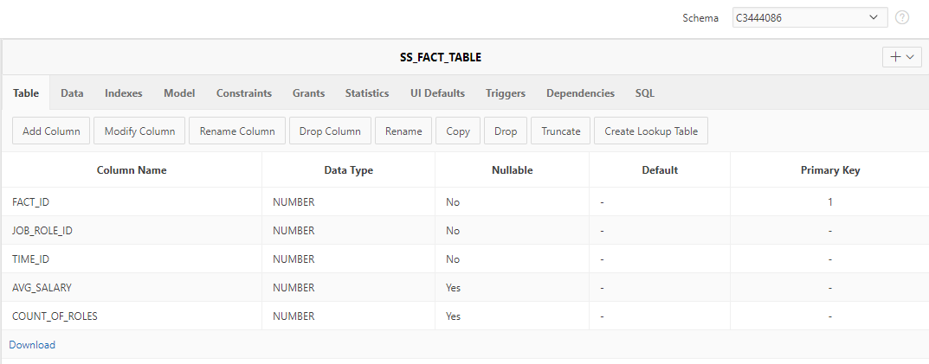

## Staging Area

Build a cleansing area where the data will first be loaded for checks quality checks. NOT NULL constraints have not been made here because we want the data in one place, regardless of quality, to simplify the error checking process by looking at a single table.

CREATE TABLE ss_temp_unclean (

placement_id VARCHAR2(255),

job_role VARCHAR2(255),

year INTEGER,

quarter INTEGER,

actual_salary INTEGER

);

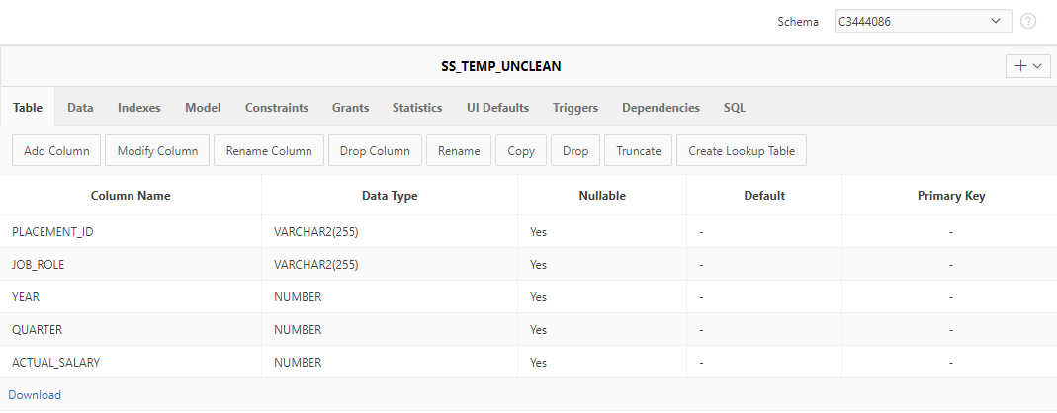

Create a clean data table where checked and clean data will be placed before being put on the SS tables. Constraints now added.

CREATE TABLE ss_temp_clean (

placement_id VARCHAR2(255) NOT NULL,

job_role VARCHAR2(255) NOT NULL,

year INTEGER NOT NULL,

quarter INTEGER NOT NULL,

actual_salary INTEGER NOT NULL,

CONSTRAINT pk_placement_id PRIMARY KEY ( placement_id )

);

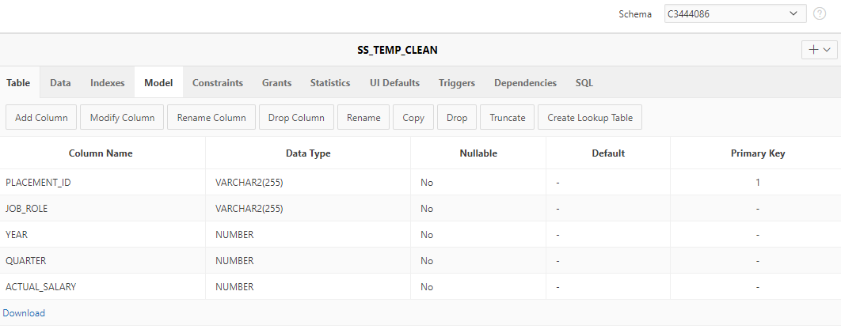

## Designing the Audit Log

The Audit log will log any potential issues with the data and add error codes to identify what type of data error it is for precision checking.

Error codes examples:

err:1 = Invalid Data

err:2 = IS NULL

err:3 = Abnormal Value

Audit logging will be triggered whenever an item is added to the ss_temp_unclean table.

DROP SEQUENCE audit_seq;

CREATE SEQUENCE audit_seq START WITH 1 INCREMENT BY 1;

CREATE TABLE ss_audit_log (

log_id INTEGER NOT NULL,

id_of_occurrence VARCHAR2(255),

errcode VARCHAR2(8),

col VARCHAR2(255),

message VARCHAR2(255),

item_in_question VARCHAR2(255),

time_stamp DATE,

checked VARCHAR2(16),

CONSTRAINT pk_log_id PRIMARY KEY ( log_id )

);

CREATE OR REPLACE EDITIONABLE TRIGGER "AUDIT_LOGGER" AFTER

INSERT ON ss_temp_unclean

BEGIN

Find any dates that are greater than the current date and log it.

INSERT INTO ss_audit_log

( SELECT

audit_seq.NEXTVAL,

placement_id,

'err:1',

'year',

'Invalid Date. Greater than current date!',

year,

SYSDATE,

'Unchecked'

FROM

ss_temp_unclean

WHERE

year > EXTRACT(YEAR FROM SYSDATE)

);

Check if Job role is null.

INSERT INTO ss_audit_log

( SELECT

audit_seq.NEXTVAL,

placement_id,

'err:2',

'job_role',

'Is Null!',

'(null)',

SYSDATE,

'Unchecked'

FROM

ss_temp_unclean

WHERE

job_role IS NULL

);

Find Potential Outliers that may be errors i.e. a value that is dispersed so abnormally far from the median. Can be reused if values change across time as it dynamically assesses the median.

INSERT INTO ss_audit_log

( SELECT

audit_seq.NEXTVAL,

ss_temp_unclean.placement_id,

'err:3',

'actual_salary',

'Value abnormally far from the median!',

actual_salary,

SYSDATE,

'Unchecked'

FROM

ss_temp_unclean

INNER JOIN (

SELECT

placement_id,

abs(actual_salary - med) AS dispersion_from_median

FROM

(

SELECT

MEDIAN(actual_salary) AS med

FROM

ss_temp_unclean

),

ss_temp_unclean

) r ON r.placement_id = ss_temp_unclean.placement_id

WHERE

--Coefficient may need to be adjusted. Dependent on what the client boundaries are.

dispersion_from_median >= 10 * (

SELECT

MEDIAN(actual_salary) AS med

FROM

ss_temp_unclean

)

);

END;

/

ALTER TRIGGER "AUDIT_LOGGER" ENABLE;

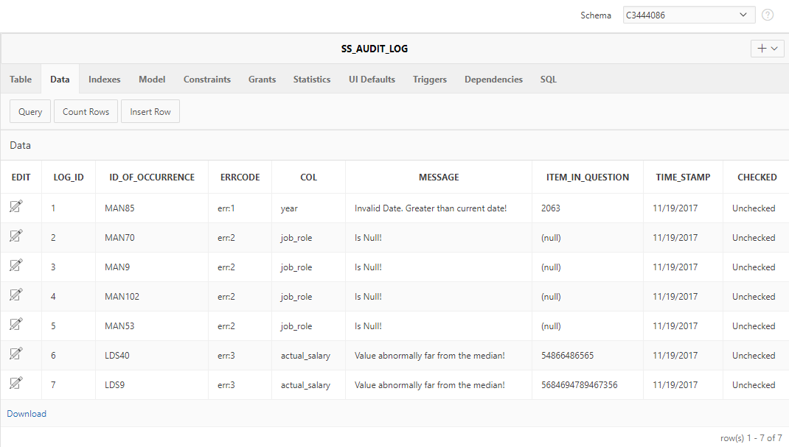

## Load the data from the Leeds and Manchester placement tables.

ID has been made unique by concatenating a prefix onto the original ID. This was done because else we would have matching instances of id coming from both tables. Done a join on the Leeds placement table because the actual job role was referenced by a foreign key to the job_role table. Lowercase all job titles for easier LIKE comparisons.

INSERT INTO ss_temp_unclean

( SELECT

'LDS'

|| placement_id,

lower(lds_job_role.job_role_desc),

EXTRACT(YEAR FROM plt_required_start_date) AS year,

TO_CHAR(TO_DATE(plt_required_start_date, 'DD/MM/YYYY'), 'Q') AS quarter,

actual_salary

FROM

lds_placement

INNER JOIN lds_job_role ON lds_job_role.job_role_id = lds_placement.fk3_job_role_id

UNION

SELECT

'MAN'

|| placement_id,

lower(plt_short_desc),

EXTRACT(YEAR FROM plt_required_start_date) AS year,

TO_CHAR(TO_DATE(plt_required_start_date, 'DD/MM/YYYY'), 'Q') AS quarter,

actual_salary

FROM

su_job

);

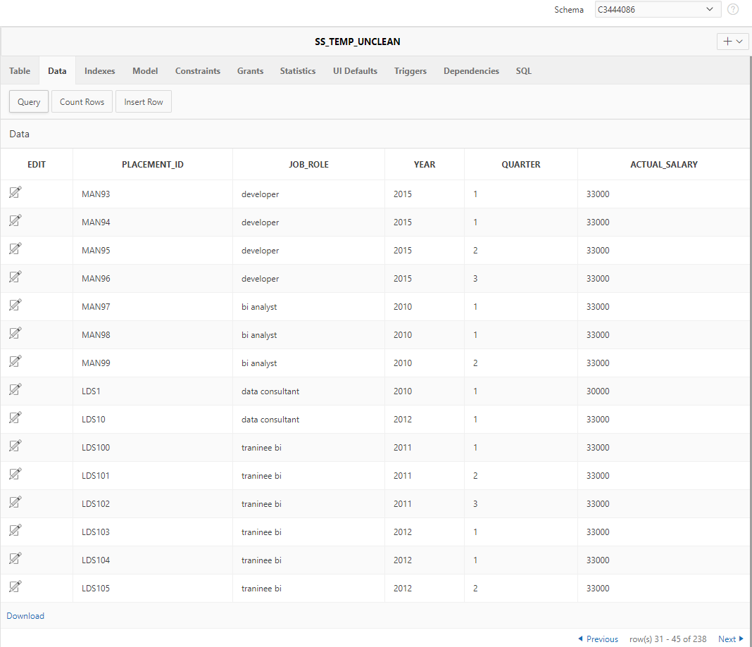

## Check the audit log for issues

Make NULL job_role values 'Unknown'. These will still be inserted into the star schema because report may not be dependent on known job_role values, namely, a report could be that we want to analyse the unknown roles in some manner.

UPDATE ss_temp_unclean

SET

job_role = 'Unknown'

WHERE placement_id IN(

SELECT

placement_id

FROM

ss_audit_log,

ss_temp_unclean

WHERE

ss_temp_unclean.placement_id = ss_audit_log.id_of_occurrence

AND ss_audit_log.errcode LIKE '%err:2%'

);

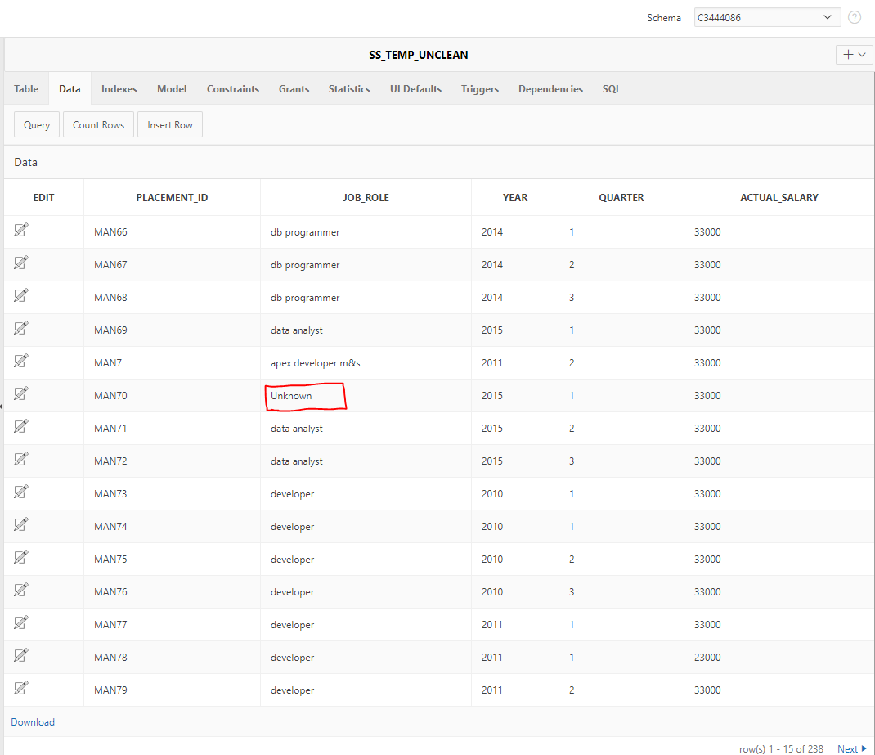

Update the audit to say that the value has been checked.

UPDATE ss_audit_log

SET

checked = 'checked'

WHERE col LIKE '%job_role%' AND errcode LIKE '%err:2%';

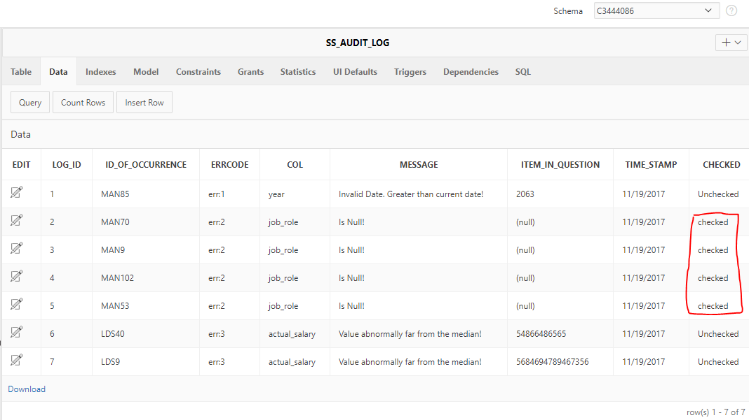

## Insert cleaned values into the final temporary table.

Because of the nature of the reports that this data mart will support, I needed to completely remove any of the values because they will affect the statistical values needed to create an accurate report. Cannot replace the salaries with values that may, for example, affect the mean, max or min. Removing them will keep the reports accurate. The same goes for years and groupings on rolling averages.

To filter out the unwanted values, the audit contains a checked column the specifies whether it is okay to enter the values into the dimensions, this is referred to by a subquery.

INSERT INTO ss_temp_clean

( SELECT

placement_id,

job_role,

year,

quarter,

actual_salary

FROM

ss_temp_unclean

WHERE

placement_id NOT IN (

SELECT

id_of_occurrence

FROM

ss_audit_log

WHERE

ss_audit_log.checked LIKE '%Unchecked%'

)

);

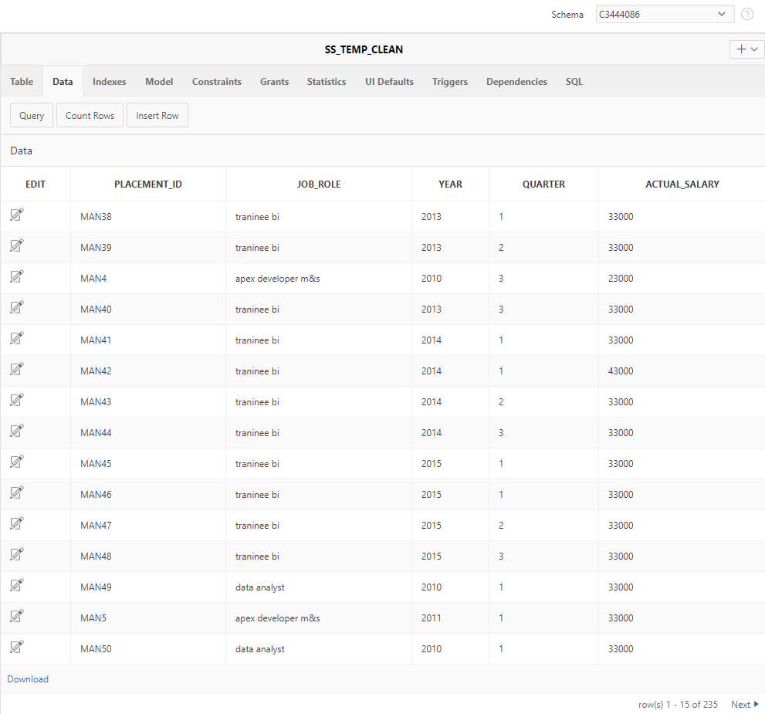

## Populate the Dimensions

INSERT INTO ss_time_dim(

SELECT time_seq.NEXTVAL, quarter, year FROM(

SELECT quarter, year, COUNT(*) AS No_Of_Placements

FROM ss_temp_clean

GROUP BY quarter, year

ORDER BY year ASC)

);

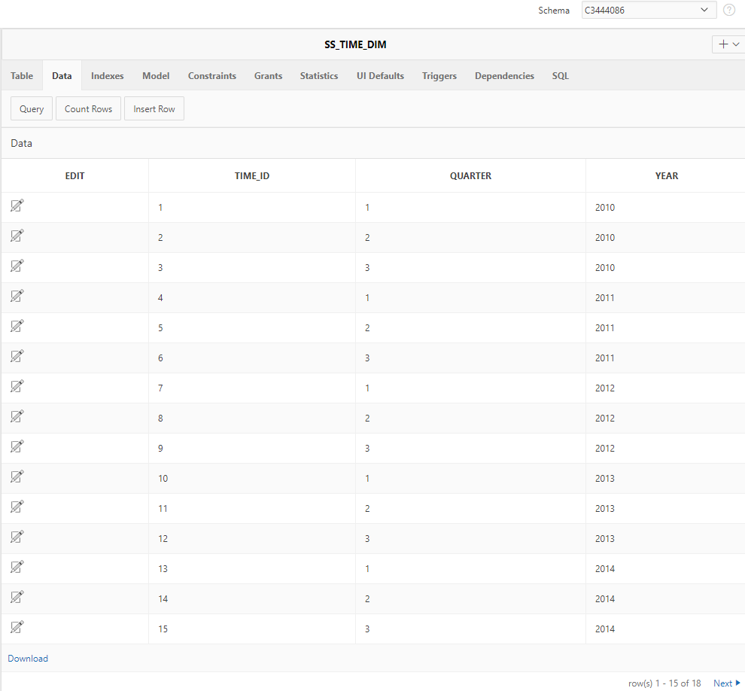

INSERT INTO ss_job_role_dim(

SELECT job_role_dim_seq.NEXTVAL ,job_role FROM (

SELECT job_role FROM ss_temp_clean GROUP BY job_role)

);

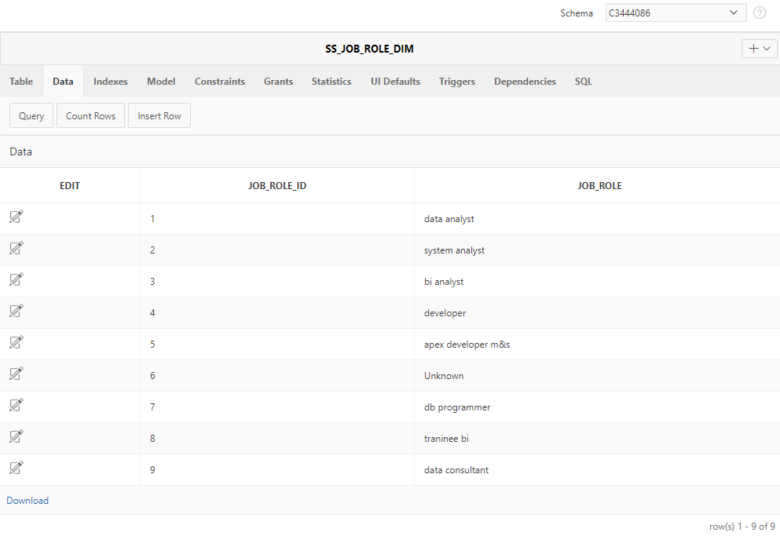

## Populate the fact table

INSERT INTO ss_fact_table(

SELECT fact_table_seq.NEXTVAL, job_role_id, time_id, Average_Salary, Count_of_roles FROM (

SELECT ss_job_role_dim.job_role_id, ss_time_dim.time_id, ROUND(AVG(ss_temp_clean.actual_salary),2) AS Average_Salary ,COUNT(*) AS Count_of_roles

FROM ss_temp_clean

INNER JOIN ss_time_dim ON ss_time_dim.year = ss_temp_clean.year AND ss_time_dim.quarter = ss_temp_clean.quarter

INNER JOIN ss_job_role_dim ON ss_job_role_dim.job_role = ss_temp_clean.job_role

GROUP BY ss_job_role_dim.job_role_id, ss_time_dim.time_id

)

);

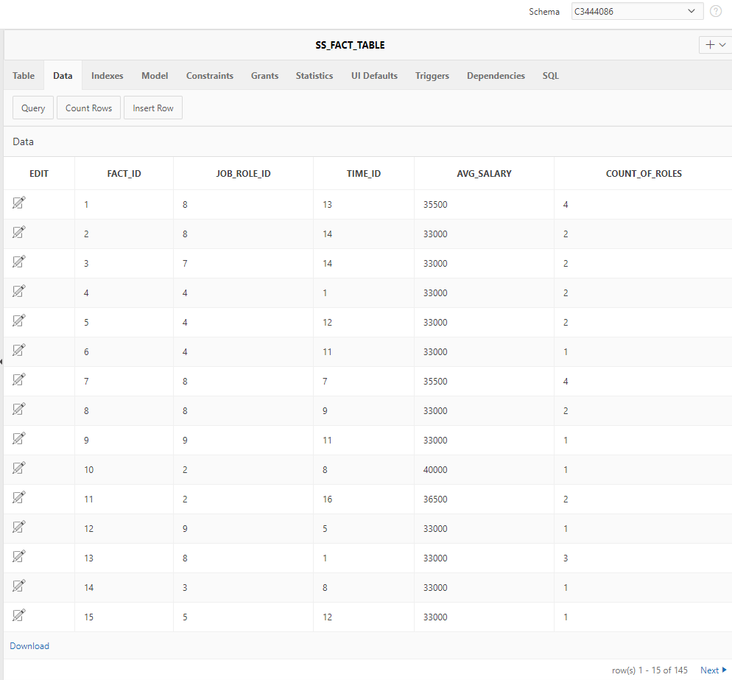

Script Results

